**REPORT**

|  |
| --- |
| **Experiment 1: RC Circuit** |

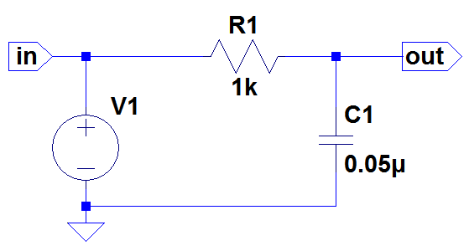

1.

|  |  |  |  |
| --- | --- | --- | --- |
| Frequency (Hz) | 5K | 10K | 15K |
| Vout,pp(V) | 5.0725 | 2.9790 | 2.0934 |

**ADJUST THE OSCILLOSCOPE APPROPRIATELY**

5k Hz Vin and Vout waveform

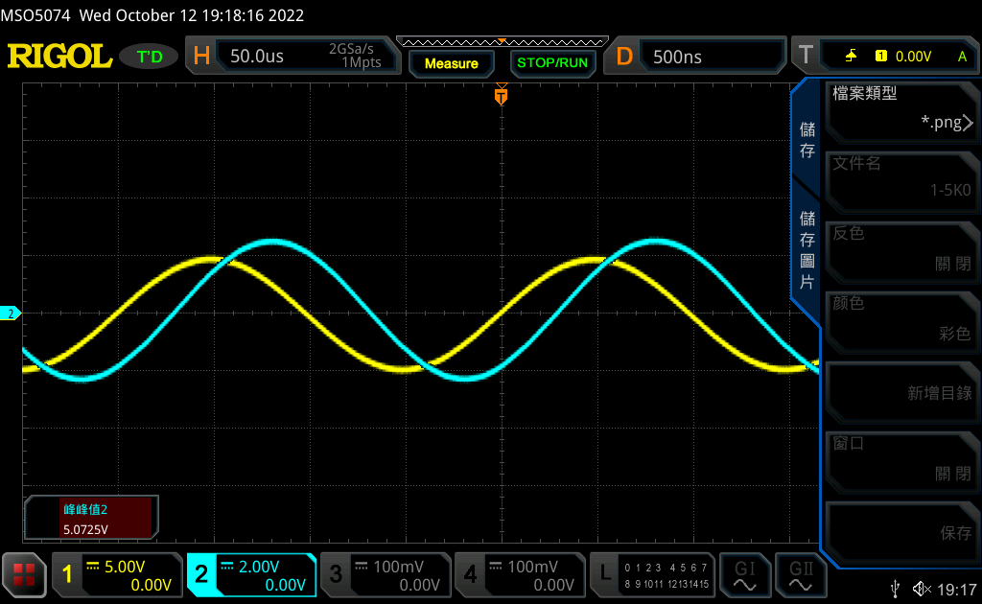

10k Hz Vin and Vout waveform

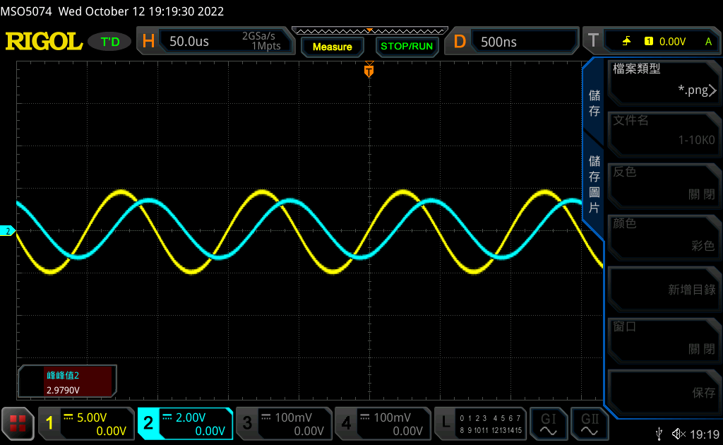

15k Hz Vin and Vout waveform

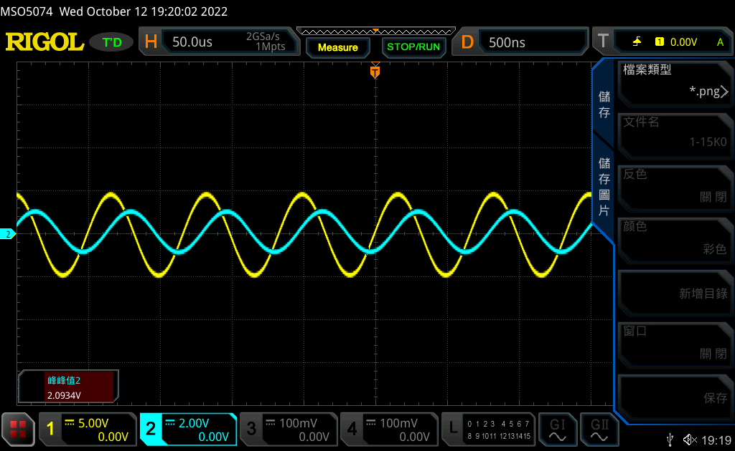

2.Vin and Vout waveform

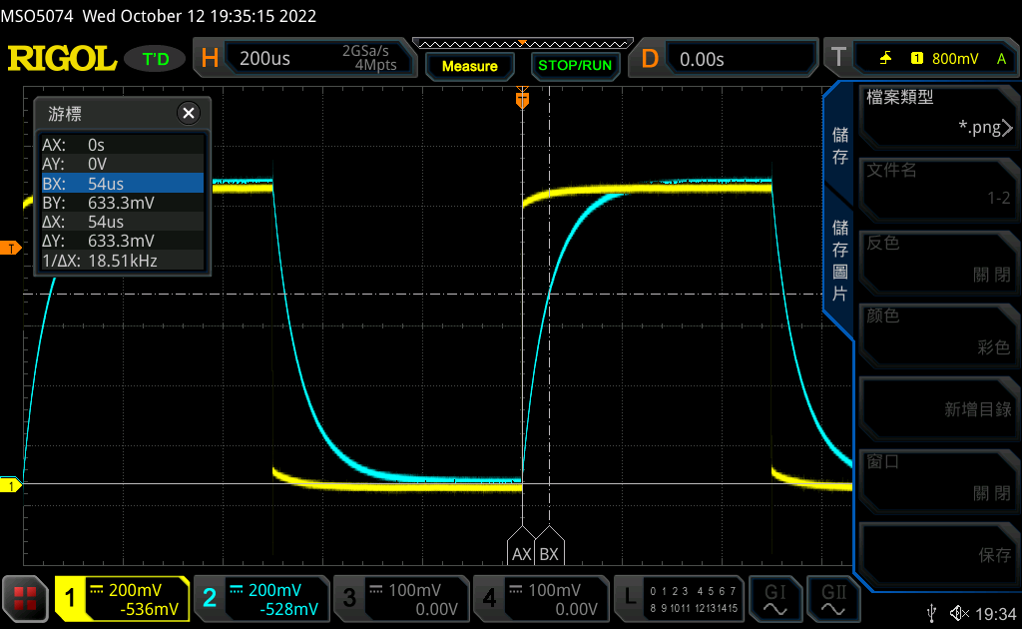

time constant =Δt = Δx = 54u second (i.e. the value you use “cursor” function to measure )

Question:

Please use KVL and KCL to derive vout function. (You need to show full solving process. NOT ONLY THE ANSWER)

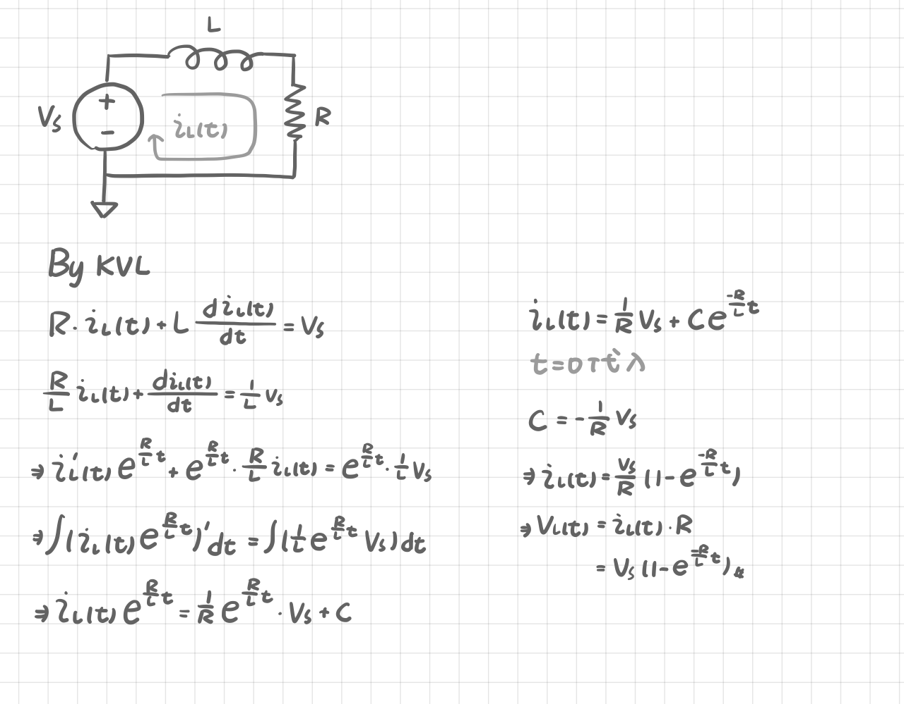

Please use variable to answer what the time constant is equal to.

(time constant) = R*C = 1k*0.05μ = 0.05m = 50μ(s) (R=1k, C=0.05μF)

Please attach your LTSPICE simulation result for this experiment. (Both waveform and schematic)

**Hint: Lab03**

Waveform

1. Sine wave:

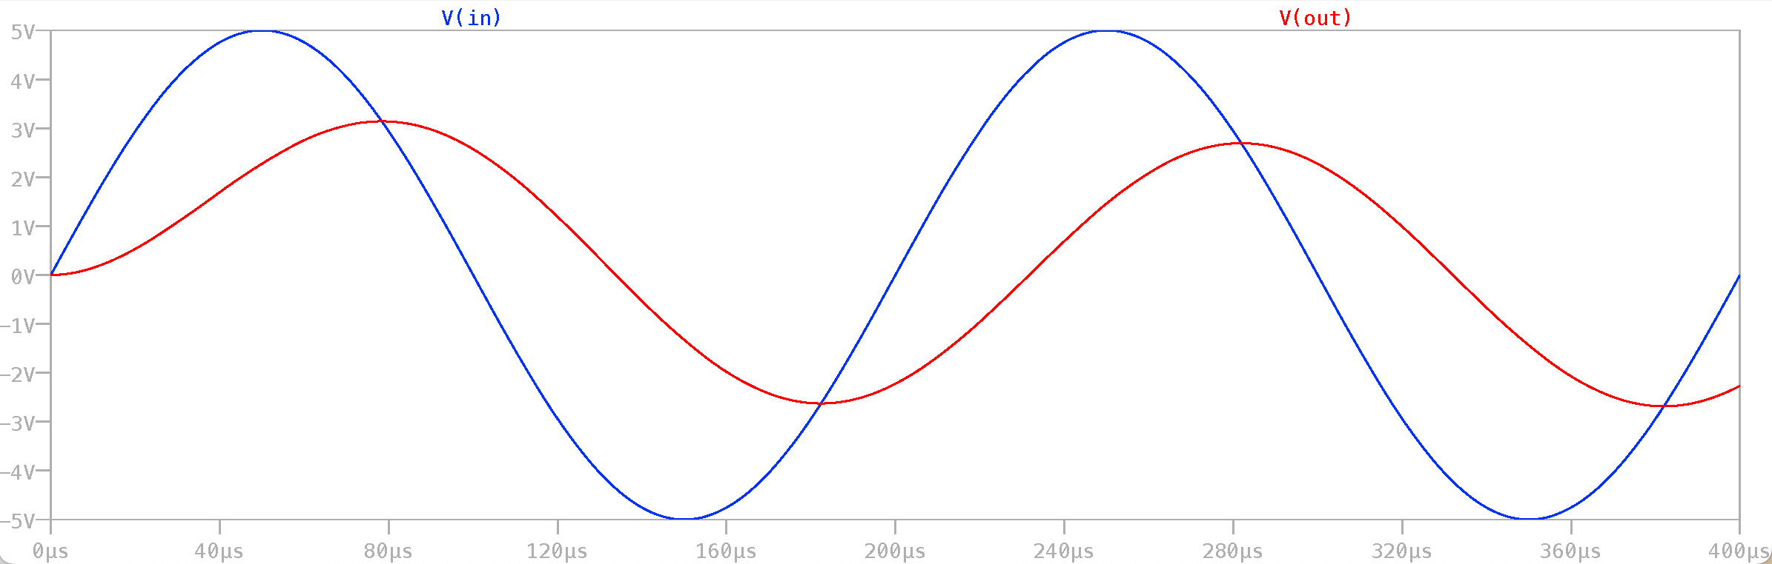

1. Square wave:

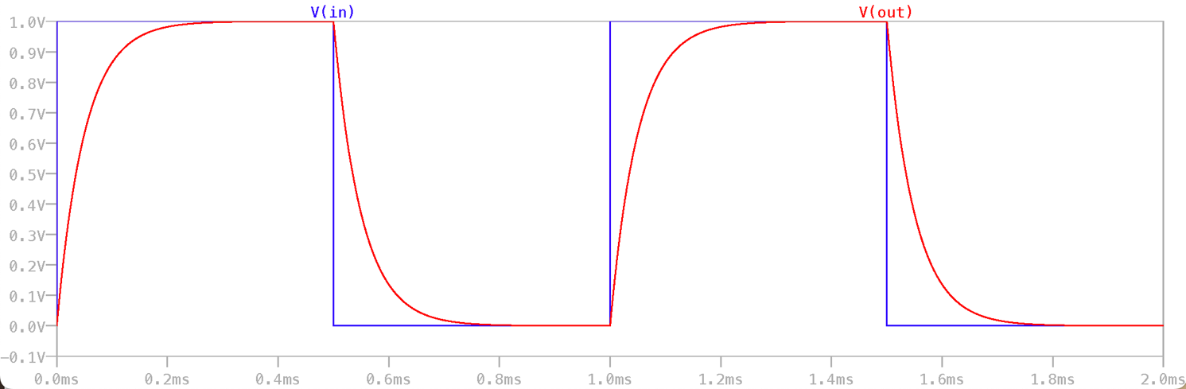

Schematic

1. Sine wave:

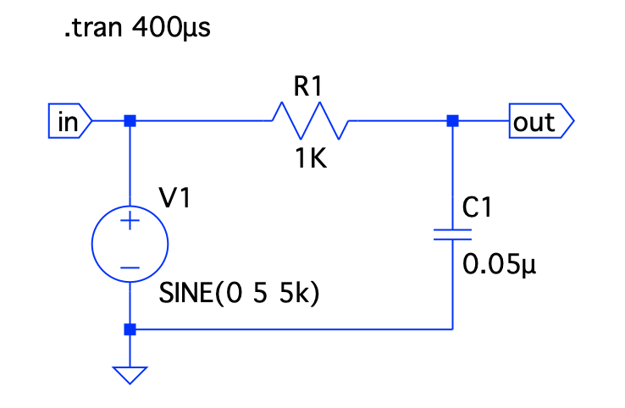

1. Square wave:

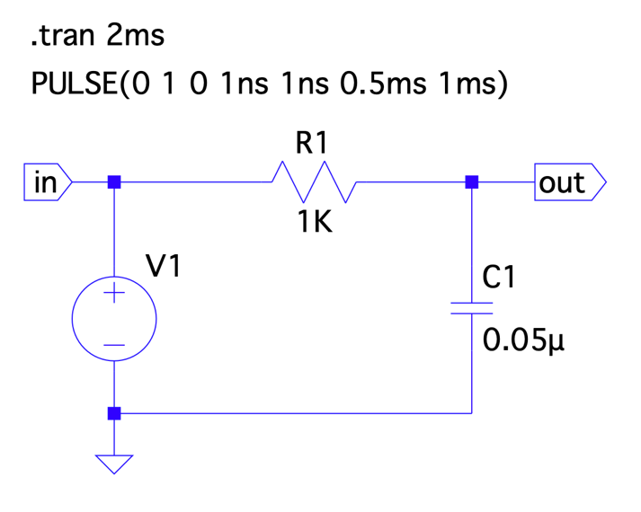

Please verify if the experiment data is satisfied with simulation results and hand calculations. Are there any differences?

|  |  |  |  |
| --- | --- | --- | --- |
|  | 實驗測量值 | LTspice模擬值 | 理論值 |
| Vout | 4.9919V | 5.76V | 5.76V |
| τ (time constant) | 54μs | 50μs | 50μs |

在計算理論值時我們並沒有將電源供應器中的內電阻納入考量，才會使得理論值計算出來的time constant較小。

Do you find anything about the relationship between output signal and input frequency?

隨著頻率增高，示波器所顯示的波形振幅會不斷變小，也就是Vout,pp所測量出來的值越小。

根據 可推得頻率越高電容阻抗也會隨之上升。此外藉由電路圖我們也可以發現隨著電容阻抗的上升，電阻所被分配到的電壓便會減少，因此Vout,pp便會減小。

發現問題

電阻和電容的輸出會有電位差的產生，而且會隨著輸入頻率增加而上升。這是因為電源供應器會先對電容進行充電，使得通過電容的電流急遽上升。而通過電阻前的電壓又會領先通過電阻的電壓，因此在測量 RC 電路時才會測到相位差。此外當頻率越高，電容容抗越高，造成的相位差便會更大。

|  |
| --- |
| **Experiment 2: RL Circuit** |

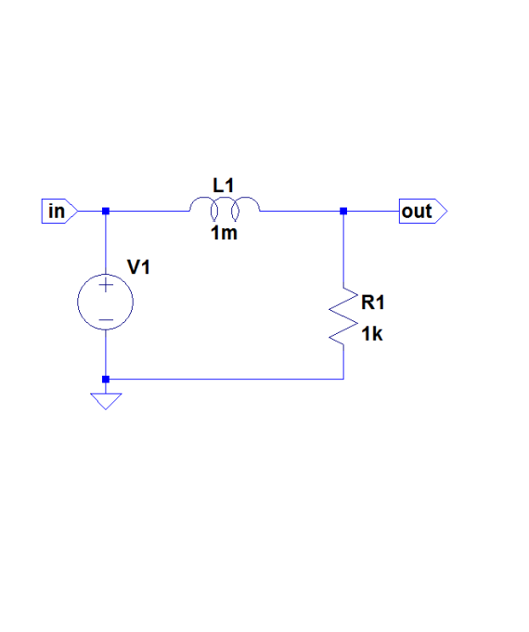

1.

|  |  |  |  |
| --- | --- | --- | --- |
| Frequency (Hz) | 100K | 200K | 300K |
| Vout,pp(V) | 8.7762 | 7.0048 | 5.636 |

**ADJUST THE OSCILLOSCOPE APPROPRIATELY**

100k Hz Vin and Vout waveform

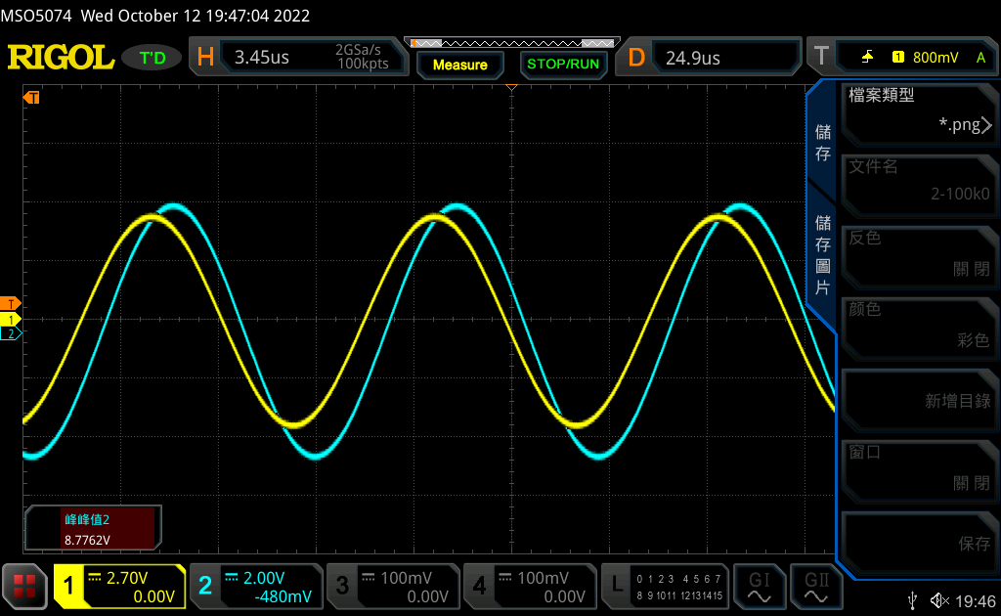

200k Hz Vin and Vout waveform

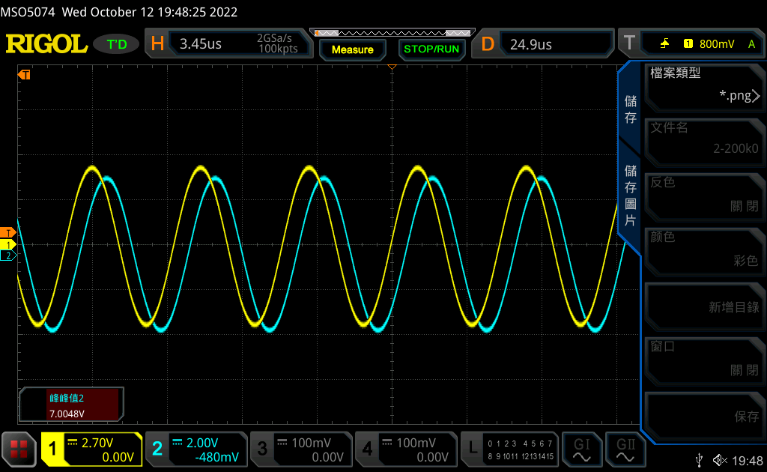

300k Hz Vin and Vout waveform

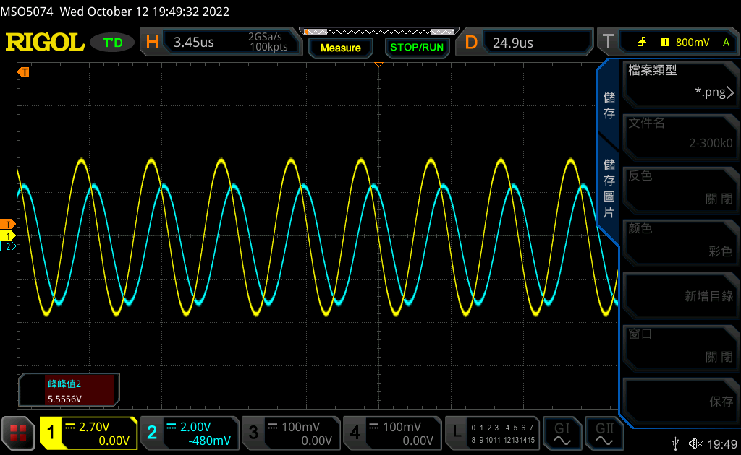

2.

Vin and Vout waveform

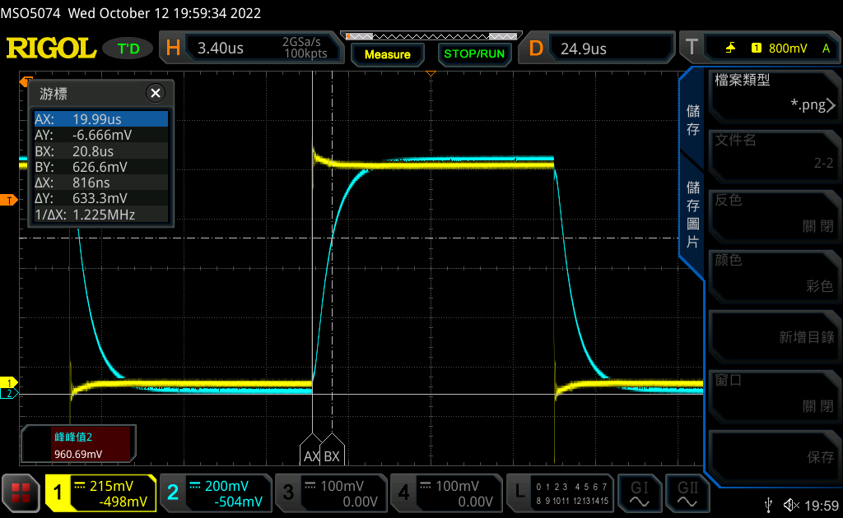

time constant =Δt = Δx = 0.8us second (i.e. the value you use “cursor” function to measure )

Question:

Please use KVL and KCL to derive vout function. (You need to show full solving process. NOT ONLY THE ANSWER)

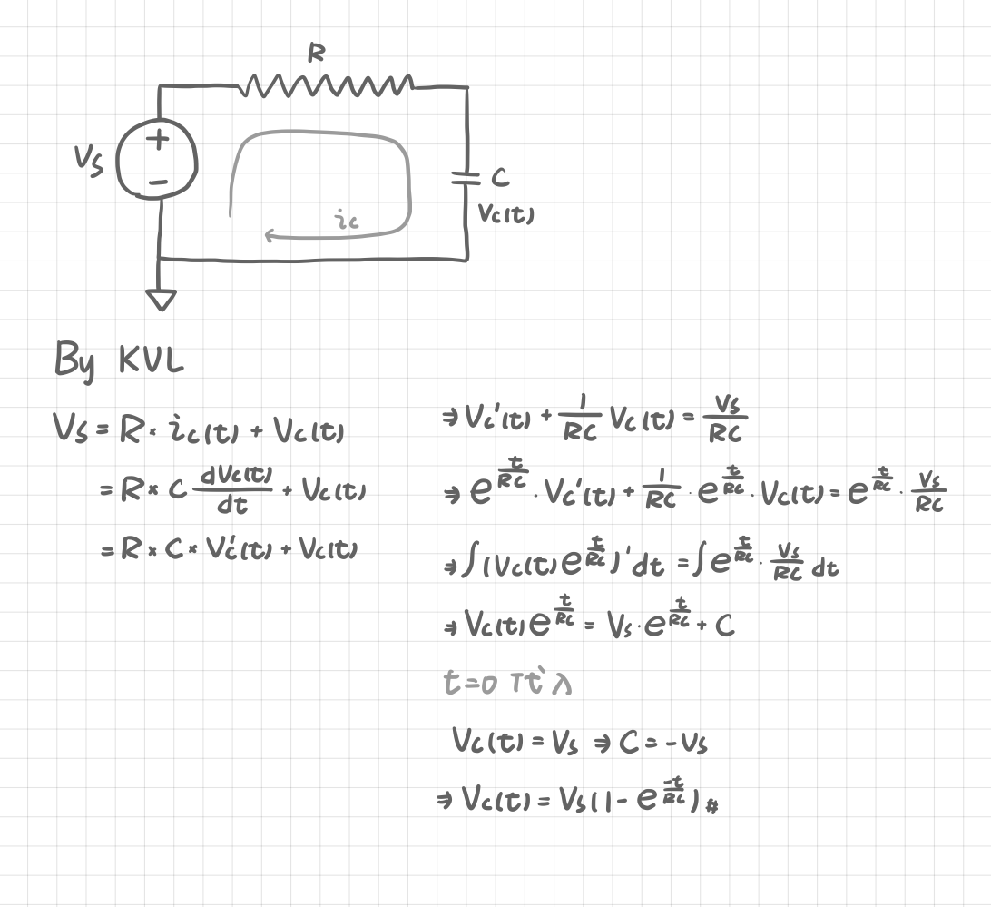

Please use variable to answer what the time constant is equal to.

(time constant) = L/R = 1m/1k = 1μ(s) (R=1k, L=1mH)

Please attach your LTSPICE simulation result for this experiment. (Both waveform and schematic)

**Hint: Lab03**

waveform

1. Sine wave:

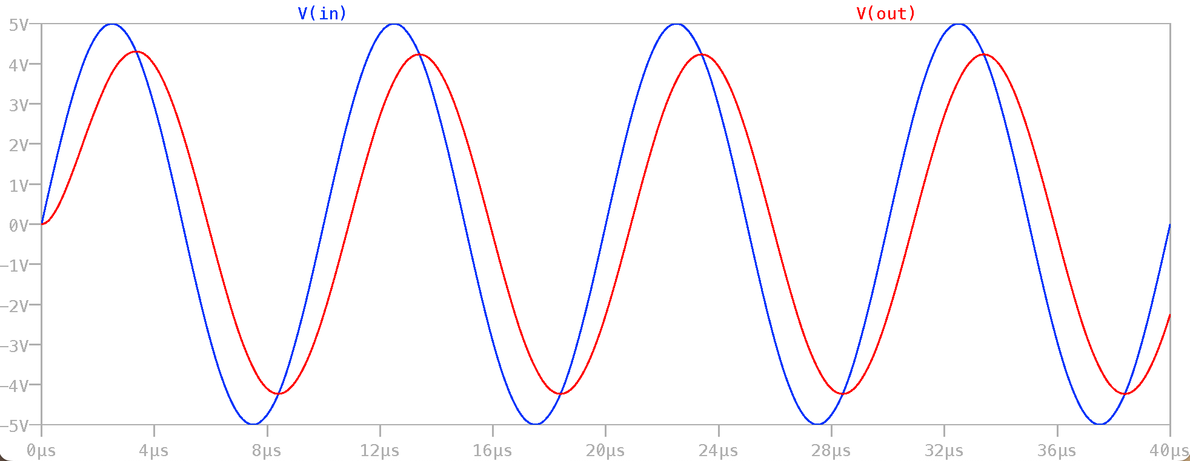

(2) Square wave:

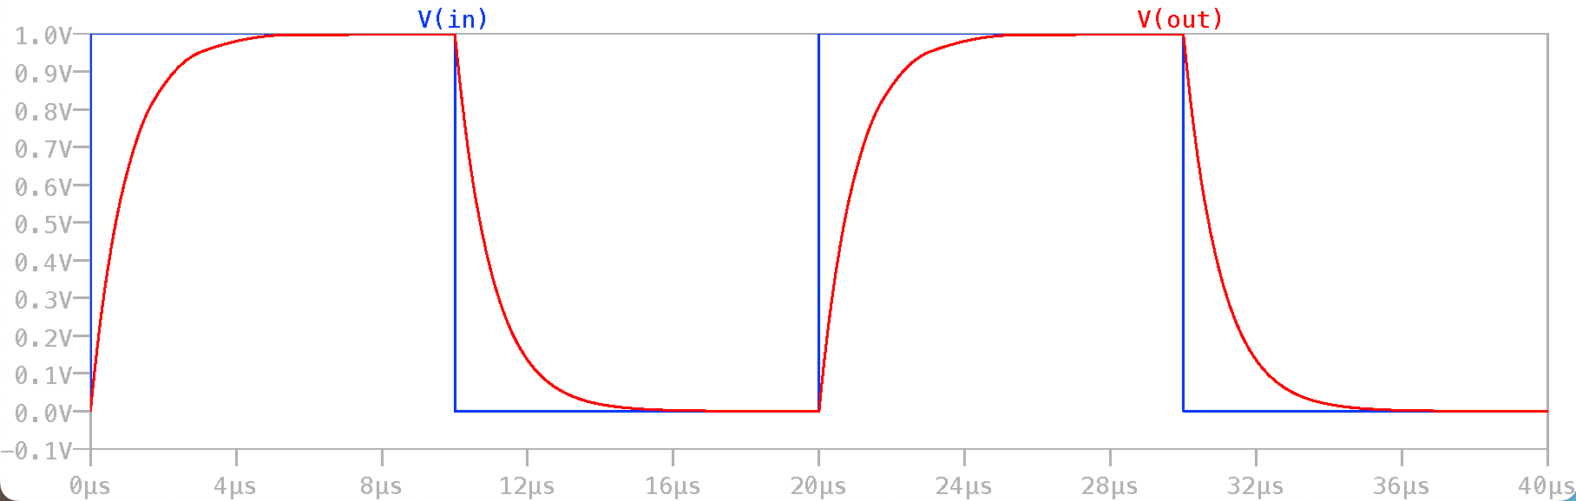

Schematic

1. Sine wave:

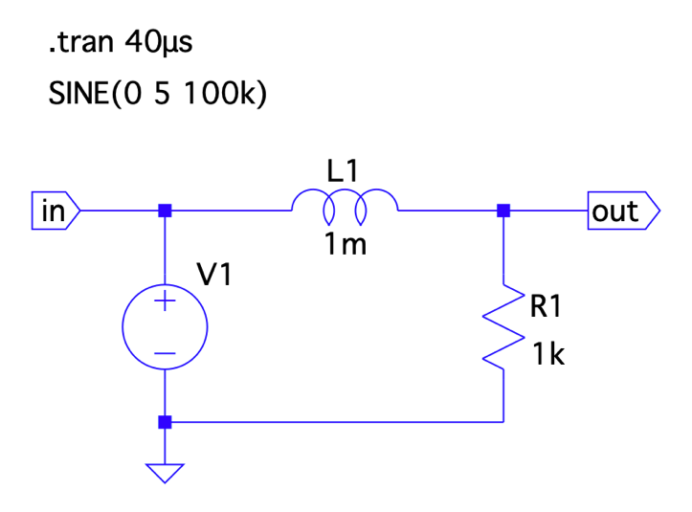

1. Square wave:

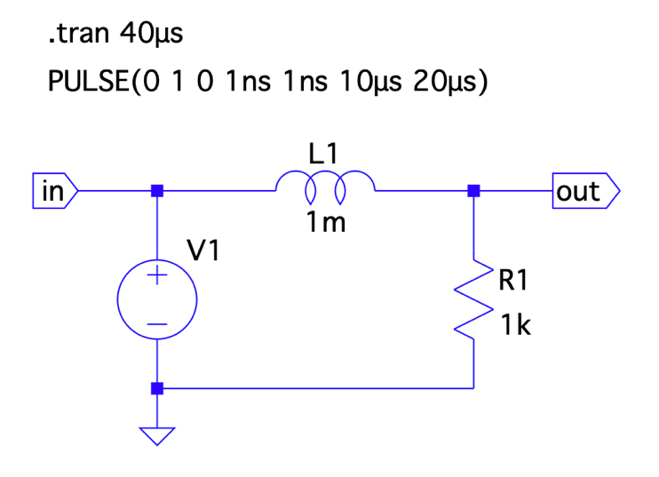

Please verify if the experiment data is satisfied with simulation results and hand calculations. Are there any differences?

|  |  |  |  |
| --- | --- | --- | --- |
|  | 實驗測量值 | LTspice模擬值 | 理論值 |
| Vout | 8.7762V | 8.6V | 8.6V |
| τ (time constant) | 0.8μs | 1μs | 1μs |

Do you find anything about the relationship between output signal and input frequency?

隨著頻率增高，示波器所顯示的波形振幅會不斷變小，也就是Vout,pp所測量出來的值越小。

根據 可推得頻率越高電容阻抗也會隨之上升。此外藉由電路圖我們也可以發現隨著電容阻抗的上升，電阻所被分配到的電壓便會減少，因此Vout,pp便會減小。

發現問題

電阻和電容的輸出會有電位差的產生，而且會隨著輸入頻率增加而上升。這是因為電源供應器會先對電容進行充電，使得通過電容的電流急遽上升。而通過電阻前的電壓又會領先通過電阻的電壓，因此在測量 RC 電路時才會測到相位差。此外當頻率越高，電容容抗越高，造成的相位差便會更大。

|  |
| --- |
| **Experiment 3: Speaker properties and signal sound** |

**ADJUST THE OSCILLOSCOPE APPROPRIATELY**

1.

waveform for FG + OSC

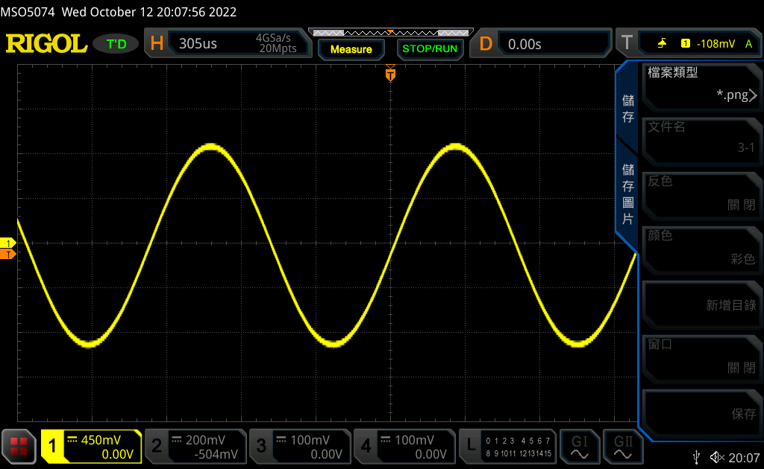

2.

waveform for FG + OSC + Speaker

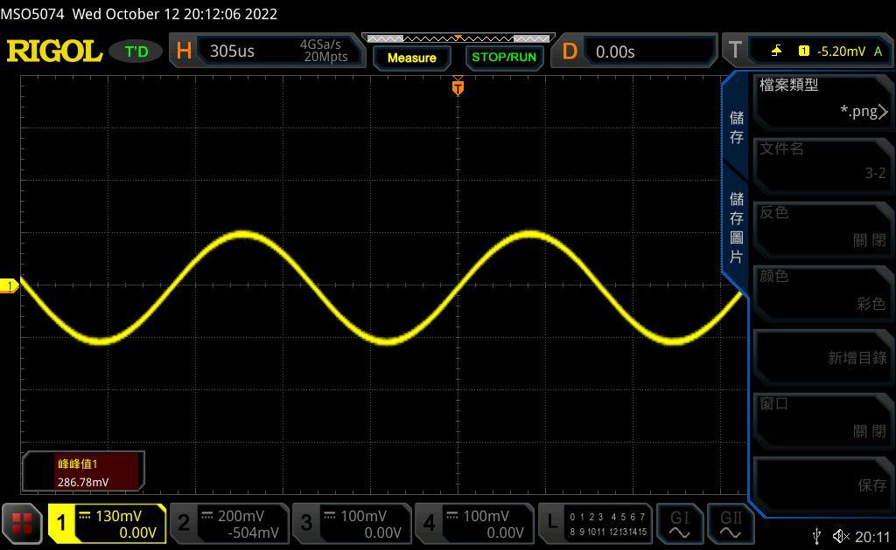

|  |  |
| --- | --- |
| **Configuration** | **Vpp of OSC CH1 (V)** |
| FG + OSC | 2.0413V |
| FG + OSC + Speaker | 286.78mV |

Question:

Are there any differences between these two connections?

在「FG + OSC + Speaker」的情況下測量得到的電壓數值較小，因為原本只有「FG + OSC」時電壓會直接輸出，但加上Speaker之後會有一部份的電壓供應給Speaker使用，所以最後「FG + OSC + Speaker」測量出來的電壓才會比只有「FG + OSC」時小很多。

Can you explain the phenomena? Hint: voltage divider

藉由已知電阻數值（喇叭電阻: 8Ω, 函數產生器之內電阻: 50Ω）配合電壓分配定律，我們可以得到

OSC在CH1的Vpp ＝ 2.03*8/(50+8+1) = 275.25 mV

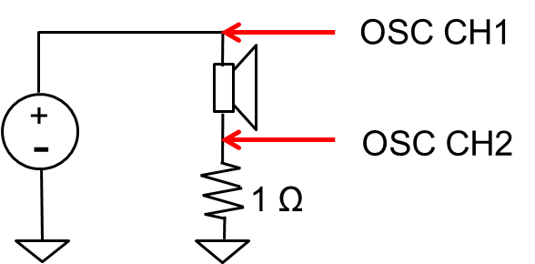

3.

①

CH 2 leads CH 1 by 8.3306 degree.

CH1 and CH2 waveform (1 KHz)

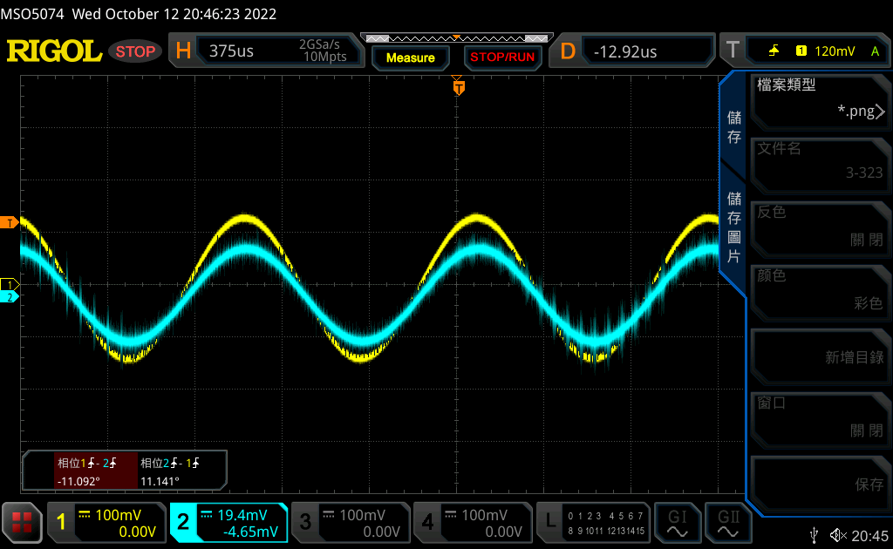

X-Y mode plot

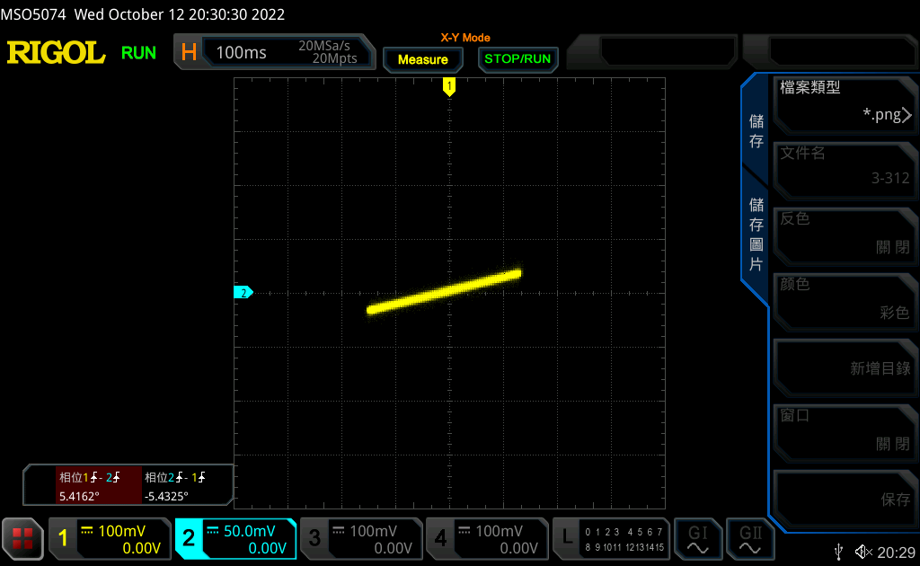

②

CH 1 leads CH 2 by 21.870 degree.

CH1 and CH2 waveform (10 KHz)

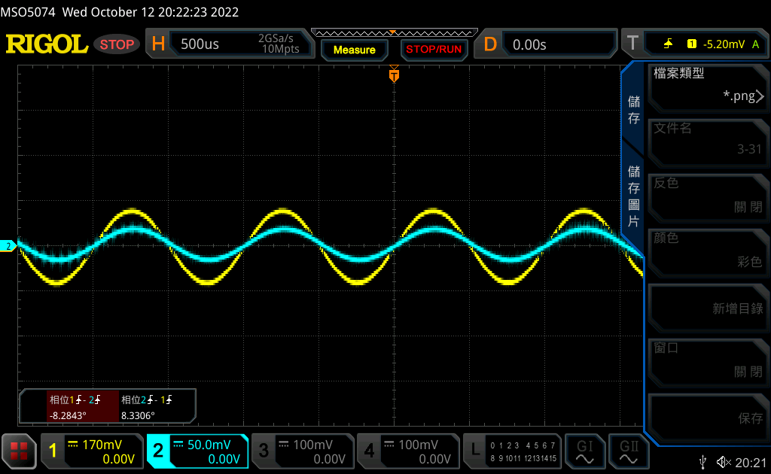

X-Y mode plot (10 KHz)

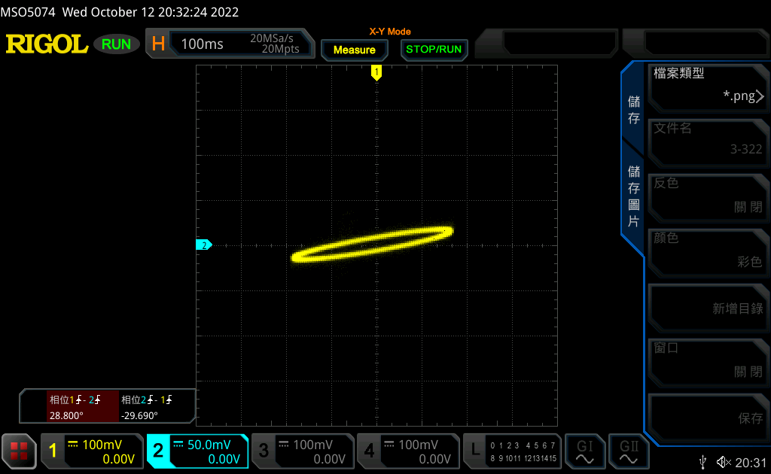

Question:

Use the following configurations to simulate Exp3-3① and Exp3-3②

|  |  |  |  |
| --- | --- | --- | --- |
| Circuit Model | Inductor Attribute | Shape | Frequency (Hz) |
|  |  | sine | 1k |
| 10k |

Please attach your LTSPICE simulation result for this experiment. (Both waveform and schematic)

Exp3-3①

waveform

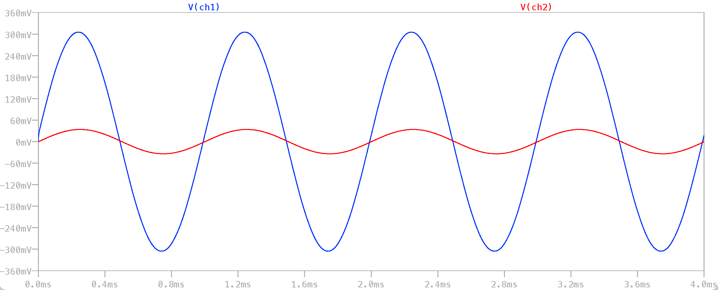

schematic

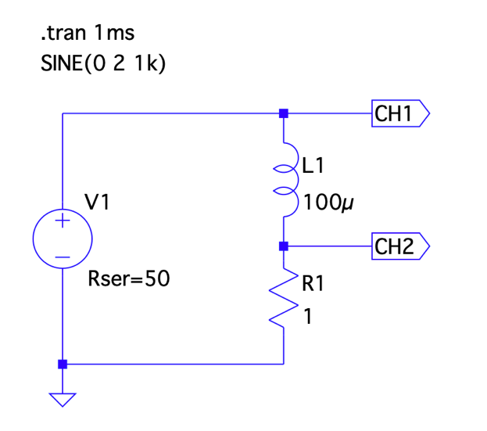

Exp3-3②

waveform

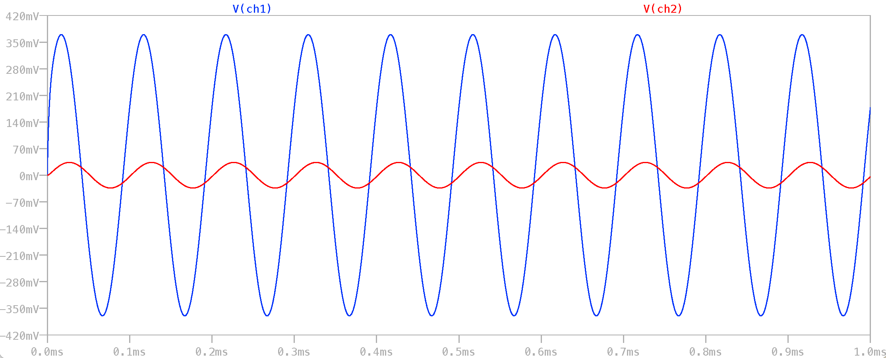

schematic

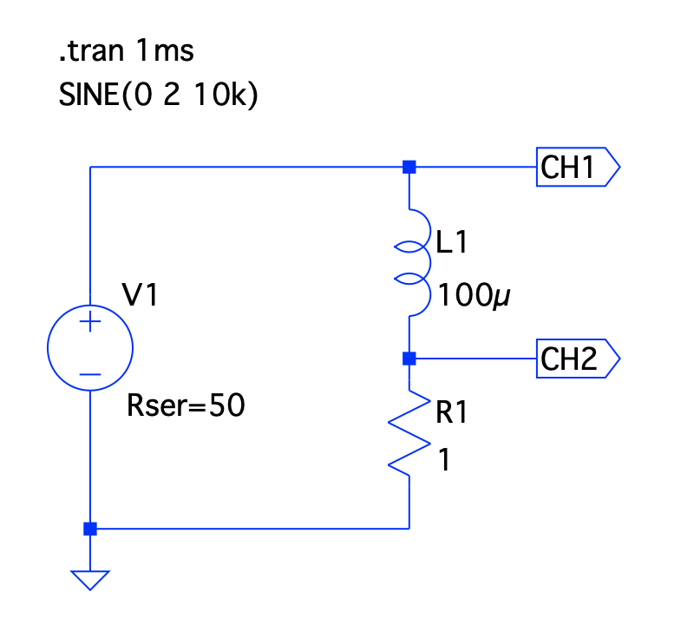

4.

Question:

Please describe the sound produced by different shape.

Sine: 聲音在三者的中間，較為圓潤

Square: 聲音較大且尖銳刺耳

Ramp: 聲音最小且有一種聲音出不來的感覺

發現問題

因為喇叭是電抗性元件，它的電阻值會隨著發出聲音的頻率不同及其他因素而改變、一直跳動，因此在產生電壓波形圖時示波器上的波形會不斷地跳動，不管如何調整trigger都一樣。這也造成了在記錄波形及相位差時的困難。只能在測量時暫時關閉波形圖的輸出，將波形定格在隨機時間後再進行測量，但每次定格後所記錄的相位差差異我認為有著極大的不同，希望能夠在後續的實驗中了解要如何解決這種的實驗問題。

實驗心得

把電路圖轉到麵包板上需要對麵包板的結構特別熟悉，尤其是知道等電位的插孔，才不會產生把電容及電阻插在聯通的橫列上。此外這次產生波形的時候對於trigger仍然不夠熟悉，所以常常會出現波形一直跳動但找不到特定的trigger值使其固定的情況，希望之後有機會可以多練習輸出波形。不過第二次產生波形有相較於第一次時更加熟悉了。

Reference

<https://subig1957.pixnet.net/blog/post/17151241>